**A REPORT**

**ON**

**Streak - Medico Hospital Management System**

**By**

**Name (s) of the student (s) Registration No.**

Purna Jear Swami Kesavapatnam AP21110010035

**Prepared in the partial fulfillment of the**

Summer Internship Course

**AT**

**Agumentik Group of Companies**

**Bengaluru, India**



**SRM UNIVERSITY, AP**

**(July, 2023)**

**COMPLETION CERTIFICATE**

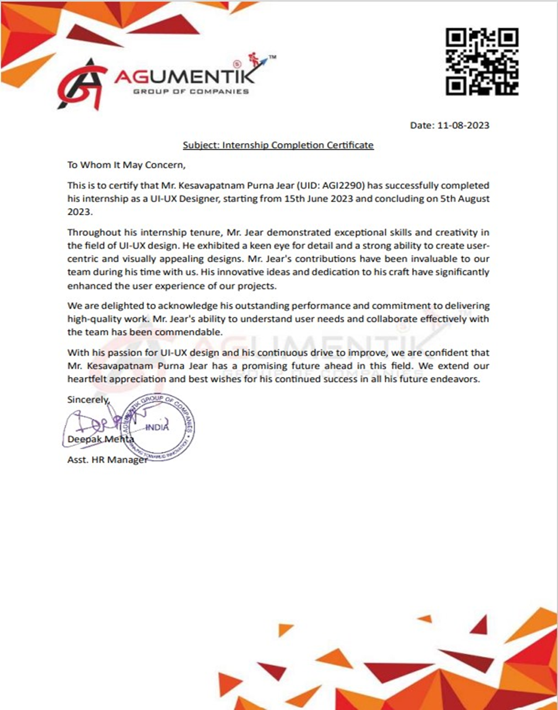

Format of Joining Report

**SUMMER INTERNSHIP COURSE,2023-24**

**JOINING REPORT**

**(To be sent within a week of joining to the University -Joining report to be uploaded online through**

**Google Form circulated by Associate Dean, Practice School)**

**Date: 11-08-2023**

| **Name of the Student** | **Purna Jear Kesavapatnam** |
| --- | --- |
| **Roll No** | **AP21110010035** |
| **Programme (BTech/ BSc/ BA/MBA)** | **BTech** |
| **Branch** | **CSE** |
| **Name and Address of the Internship Company**  **[For research internship, it would be SRMAP]** | **Agumentik Group of Companies Address: 1st Floor 99/1, 99/1, PWD Rd, above Central Bank of India, Kathreguppe,**  **Banashankari 3rd Stage, Banashankari,**  **Bengaluru, Kamataka**  **560085**  **Telephone No: +91 80696 40295**  **Email: info@agumentik.com** |
| **Period of Internship** | **From 15th June 2023 to 5th August 2023** |

**I hereby inform that I have joined the summer internship on _____________________ for the In-plant Training/ Research internship in the industry.**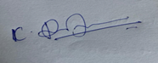

**Date : 08-10-2023 Signature of the Student**

**CERTIFICATE FROM INDUSTRY MENTOR/HR**

**(FACULTY MENTOR FOR RESEARCH INTERNSHIP)**

**Certified that the above-mentioned student has joined our organization for the INTERNSHIP / INDUSTRIAL TRAINING / ACADEMIC ATTACHMENT in the industry / Organization.**

| **Name of the Industry Mentor** | **Anup Vishal** |
| --- | --- |
| **Designation** | **Sr. Regional HR Manager** |
| **Phone No (If any)** | **+91 8069640295** |

| **Email** | **internship@agumentikgroup.com** |
| --- | --- |
| **Signature & Date** |  |

# **ACKNOWLEDGEMENT**

I want to extend my sincere gratitude to my internship supervisor and the HR team for their invaluable guidance, unwavering support, and insightful advice throughout the project's duration. Your expertise and mentorship have played a pivotal role in shaping the project's direction and successful execution.

My heartfelt thanks go out to the entire Agumentik Group of Companies for warmly embracing me into their workspace and providing an enriching environment that fostered my learning and personal growth. The collaborative and vibrant atmosphere within the organization significantly deepened my practical understanding of the real-world applications in my field of study.

I am also deeply appreciative of my colleagues and peers who generously shared their knowledge and experiences, enriching my internship journey immensely. Their readiness to offer assistance and engage in constructive discussions enhanced my learning curve substantially.

Furthermore, I extend my appreciation to my academic mentor, Dr Shuvendu Rana, for their unwavering support and motivation. Their insights and guidance proved invaluable in bridging the gap between theoretical knowledge and hands-on implementation. Lastly, my heartfelt thanks go to my family and friends for their constant encouragement, understanding, and motivation throughout the internship and project's duration.

This internship experience has significantly enriched my skill set, knowledge base, and professional development. The unwavering support and encouragement from all stakeholders have been instrumental, and I am genuinely thankful for the opportunity to contribute to the Agumentik Group of Companies and glean valuable in sights from this transformative experience.

# **ABSTRACT**

The Hospital Management Application project aims to revolutionize the healthcare sector by introducing a comprehensive digital solution for efficient patient information management and appointment booking. In response to the challenges posed by traditional paper-based systems and disjointed digital tools, this project focuses on creating a user-friendly, intuitive, and seamlessly integrated application tailored to the needs of hospitals, clinics, and medical centers.

Driven by the increasing demand for streamlined healthcare operations and enhanced patient care, the project's primary objective is to develop an application that optimizes the workflow of hospital staff. Through a meticulous process of requirements gathering, UI/UX design, and front-end development, the project endeavors to create an intuitive interface that empowers staff to manage patient records, medical histories, and appointments with utmost precision and efficiency.

The project's methodology centers around close collaboration with healthcare stakeholders, involving doctors, nurses, administrative staff, and IT professionals. By eliciting their insights and addressing their pain points, the resulting Hospital Management Application is poised to transform the way patient information is handled, ultimately contributing to a more seamless and patient-centric healthcare experience.

Key milestones include the design of a user-centric interface, informed by comprehensive user testing and feedback. The application's features encompass patient data management, medical history tracking, and appointment scheduling, all seamlessly integrated to improve data accuracy, reduce errors, and streamline administrative processes.

As a culmination of extensive design, development, and testing efforts, the Hospital Management Application is anticipated to foster a paradigm shift in healthcare administration. This project report comprehensively details the background, purpose, methodology, and anticipated outcomes of the endeavor. Through the creation of this innovative digital solution, we aspire to enhance hospital operations, elevate patient care standards, and contribute to the advancement of healthcare services in a technologically-driven era.

# **TABLE OF CONTENTS**

| **TITLE** | **PAGE NO:** |
| --- | --- |
| Internship Completion Certificate | 2 |
| Joining Report | 3 |
| Acknowledgment | 5 |
| Abstract | 7 |
| Introduction of the Organization | 10 |
| Overview of the Organization | 11 |
| Plan of Internship Program | 12 |
| Project Introduction | 16 |
| Project Description | 18 |
| Project Outcomes | 20 |
| Conclusion | 23 |
| References | 26 |

# **INTRODUCTION OF THE ORGANIZATION**

Agumentik Group, a rapidly expanding startup based in India, specializes in software design, website development, app development, animation, game design, and digital marketing services. With a strong dedication to ensuring customer success and satisfaction, Agumentik Group of Companies is a vital component of the renowned Agumentik Group, established in 2016.

# **OVERVIEW OF THE ORGANIZATION**

Agumentik, a rapidly growing startup based in India, specializes in a wide array of services including software design, website and app development, animation, game design, and digital marketing. With a strong commitment to their clients' success, Agumentik is dedicated to delivering a high level of satisfaction. Established in 2016, Agumentik Consultancy Pvt. Ltd. stands as an integral part of the esteemed Agumentik Group of Companies.

Earning recognition for its exceptional performance,

Agumentik is swiftly gaining prominence, particularly in Andhra Pradesh. The company's vision is ambitious, and they pursue success through thoughtful and strategic steps. Their approach is characterized by humility, visionary thinking, and ambitious aspirations. Within the Information and Technology Industry, Agumentik believes in the cumulative impact of numerous incremental innovations, continuously striving for slight improvements in efficiency and effectiveness.

At the heart of their operation is a relentless commitment to delivering outstanding services to their clients. With a dynamic team of young and energetic designers and developers, Agumentik is dedicated to meeting clients' specific needs. They offer a range of services including graphic design, app development, website design, game development, and digital marketing, all tailored to the demands of the moment.

**PLAN OF INTERNSHIP PROGRAM**

During my internship at Agumentik Group of Companies, my primary objective was to acquire hands-on experience and refine my skills as a UI-UX designer through active involvement in real-world projects. The core focus of this internship revolved around crafting user-centric and visually captivating interfaces for both mobile applications and websites, in harmony with the company's unwavering pursuit of excellence.

Throughout the internship duration, I was deeply engaged in shaping interfaces for three distinct mobile apps and nine website ventures. Each project's scope encompassed the following key phases:

**1.** **Collaborative Project Initiation:** I collaborated closely with project managers to comprehend client requirements and project goals thoroughly.

**2.** **User-Centric Ideation:** Through rigorous research, I gathered and assimilated user requirements, leading to the formulation of comprehensive design briefs.

**3. Structural Visualization:** I translated these insights into low-fidelity wireframes, outlining the skeletal framework and arrangement of interfaces.

**4. Interactive Prototyping:** By developing interactive prototypes, I effectively demonstrated user journeys and seamless interactions within the designs.

**5. Artful Integration:** Applying established design principles, I transformed wireframes into visually harmonious UI designs, ensuring a coherent look and feel.

**6. Visual Cohesion:** I maintained consistency in color schemes, typography, and graphic elements throughout the designs.

**7. User-Centered Approach:** Every design decision was rooted in promoting user-friendliness, accessibility, and optimal usability.

**8. Responsive Adaptation:** I ensured adaptability across diverse screen dimensions and devices, thus enhancing the overall user experience.

**9. Open Communication:** Regular and effective communication with team members, developers, and project stakeholders was integral to the process.

**10. Effective Project Management:** By adhering to project schedules and managing multiple design tasks concurrently, I contributed to streamlined project timelines.

**As the internship concluded, my overarching objectives included the following accomplishments:**

**1.** **Rich Design Portfolio:** Curating a collection of completed UI-UX design projects for both applications and websites, showcasing a diverse skill set.

**2.** **Tool Proficiency:** Improved dexterity in utilizing industry-standard tools such as Figma and Adobe XD.

**3.** **Design Philosophy:** A more profound comprehension of user-centered design principles, aligning my creative output with user needs.

**4.** **Articulate Communication:** The ability to eloquently convey design concepts and the rationale behind them, facilitating effective collaboration.

This internship at Agumentik Group of Companies proved to be an instrumental platform for honing my UI-UX design prowess, while also fostering a holistic understanding of project dynamics and collaborative teamwork.

# **INTRODUCTION**

In the era of rapid technological advancement, the fusion of design

and technology has become pivotal in shaping seamless and efficient user experiences across various domains.

As a second-year Computer Science Engineering student with a fervent passion for UI-UX design, my journey led me to a transformative internship at Augmentik Group of Solutions Pvt. Ltd. This practical exposure provided me with invaluable insights and hands-on experience, laying the foundation for my involvement in a significant project – the development of a comprehensive hospital management application.

The healthcare industry stands as a complex web of patient data, clinical histories, and intricate appointment systems. In this intricate environment, the need for a user-centric digital solution that simplifies data management and appointment coordination is paramount. The hospital management application, at the core of this

project, aspires to revolutionize hospital operations by providing a

seamless platform for staff to manage patient information, histories,

and appointments. This application is not just a technological

innovation but a design-driven solution that strives to enhance data

accessibility, streamline workflows, and ultimately uplift the quality

of patient care.

This project report encapsulates my academic and professional

journey, merging theoretical concepts with hands-on experiences

garnered from my internship. It takes you through the inception,

design, and development of the hospital management application,

highlighting the synergy between design aesthetics and technological functionality. As we delve deeper into the report, we unveil the transformative potential of UI-UX design in the healthcare sector and its ability to enhance user experiences.

Through this narrative, I aim to share the project's inception,

methodologies, outcomes, and the profound impact of combining

design thinking with technological innovation. With each section, we

embark on a journey that showcases how a passion for UI-UX design, nurtured through academic pursuits and real-world exposure, can pave the way for meaningful contributions to critical sectors such as healthcare. This report serves as a testament to the potential of a dedicated blend of design and technology, illustrating my growth as a UI-UX enthusiast and my aspirations to make a lasting impact in the world of user experience.

**DESCRIPTION**

The hospital management application project represents a culmination of my passion for UI-UX design, cultivated throughlearning and practical experiences gained during myinternship at Augmentik Group of Solutions Pvt. Ltd. Thisendeavor embodies the convergence of innovative designprinciples and cutting-edge technology to address the complexchallenges within the healthcare sector.

At its core, the hospital management application serves as adynamic digital solution tailored to meet the specific needs ofhospital staff. It offers a comprehensive platform that enablesefficient management of patient information, medical histories,and appointment scheduling. By seamlessly integrating intuitivedesign with functional features, the application empowershospital personnel to streamline their workflows, make informeddecisions, and provide enhanced patient care.One of the central facets of this project is its commitment to user-centric design. The application is meticulously crafted to ensure asmooth and engaging experience for hospital staff, focusing onsimplicity, accessibility, and visual appeal. Intuitive navigation,visually cohesive interfaces, and interactive elements contributeto a user-friendly interface that enhances productivity andminimizes potential errors.The project's development methodology reflects a comprehensiveapproach that encompasses various stages. These includecollaborating with project managers to understand user needs, conducting user research to gather requirements, creating low-

fidelity wireframes to outline interface structures, and designing

interactive prototypes to visualize user flows. The application's

design principles encompass consistency in visual elements,

prioritization of usability, and adaptability to different screen

sizes and devices.

Incorporating lessons learned during my internship, I have

employed a holistic perspective that extends beyond mere

functionality. The hospital management application is designed to

foster a sense of community by seamlessly connecting hospital

staff, facilitating communication, and enhancing collaboration.

Additionally, by allowing staff to book appointments for patients

directly within the application, the project contributes to

streamlined processes and improved patient experience.

Throughout the development journey, I have harnessed the skills

honed during my internship, leveraging industry-standard tools

and practices to ensure that the hospital management application

adheres to the highest standards of UI-UX design. The project

report further delves into the project's outcomes, revealing how

this undertaking has not only enriched my understanding of

design but has the potential to revolutionize healthcare

operations, setting a precedent for the integration of technology

and user-centric design in critical sectors.

# **OUTCOMES**

**1.** **Enhanced User Experience:** Through thoughtful UI-UX design, the hospital management application project significantly improved the user experience for hospital staff. The intuitive interface, streamlined navigation, and visually appealing design elements collectively resulted in a user-friendly and efficient platform.

**2.** **Efficient Patient Information Management:** The application's design and functionality empowered hospital staff to effectively manage patient information, medical histories, and details. The organized presentation of patient data and streamlined data entry processes contributed to enhanced operational efficiency.

**3.** **Seamless Appointment Booking:** The integration of an appointment booking feature directly within the application enabled hospital staff to conveniently schedule patient appointments with doctors. This streamlined process minimized scheduling conflicts and improved overall appointment management.

**4.** **Data Accessibility and Accuracy:** The project's focus on usability and accessibility ensured that hospital staff could easily access patient information and medical histories. This accessibility translated into improved accuracy in patient care, as staff could quickly retrieve essential data.

**5.** **Visual Consistency and Coherence:** The consistent application of design principles, such as color schemes, typography, and layout, resulted in a visually cohesive interface. This uniformity not only contributed to a polished aesthetic but also facilitated ease of use for staff.

**6.** **Informed Design Decisions:** The experience gained during the internship at Augmentik Group of Solutions Pvt. Ltd. played a pivotal role in making informed design decisions. Insights acquired from real-world projects translated into effective strategies for creating a user-centric hospital management application.

**7.** **Project Management Skills:** The project provided an opportunity to hone project management skills by adhering to timelines, coordinating with team members, and managing concurrent design tasks. This experience cultivated a better understanding of balancing design creativity with practical implementation.

**8.** **Real-world Application of UI-UX Principles:** The internship-driven project underscored the practical application of UI-UX principles learned in the academic curriculum. It showcased how design theory could be translated into tangible, functional solutions that address real-world challenges.

**9.** **Contribution to Healthcare Efficiency:** Ultimately, the outcomes of this project contribute to improving the efficiency and quality of healthcare services. By facilitating streamlined patient data management and appointment booking, the application positively impacts the daily operations of healthcare facilities.

**10. Portfolio and Skill Enrichment:** The successful completion of the hospital management application project adds valuable projects to my design portfolio and enriches my skill set as a UI-UX designer. This experience enhances my prospects for future career opportunities and continued growth in the field.

# **CONCLUSION**

In conclusion, the development of the hospital management application project has been a transformative journey that has not only deepened my understanding of UI-UX design but also demonstrated the real-world impact that thoughtful design solutions can have on enhancing operational efficiency and user experience. Through this project, I have had the opportunity to apply the knowledge and skills gained during my internship at Augmentik Group of Solutions Pvt. Ltd., further solidifying my passion for UI-UX design.

The hospital management application addresses a critical need in the healthcare sector by providing hospital staff with a user-friendly and efficient tool to manage patient information and appointments. The outcomes achieved through this project are indicative of the power of design to simplify complex processes, improve data accessibility, and streamline workflows. The intuitive navigation, visually appealing interfaces, and seamless appointment booking feature collectively contribute to an enhanced user experience for hospital staff, ultimately leading to improved patient care.

Furthermore, this project underscores the importance of collaboration and effective communication within a multidisciplinary team. The successful execution of the project required close coordination with project managers, developers, and stakeholders to ensure that the design met both functional and aesthetic requirements. This experience has honed my ability to work collaboratively in a professional setting, a skill that will undoubtedly prove invaluable in my future endeavors.

As a second-year Computer Science Engineering student with a keen interest in UI-UX design, this project has been a significant stepping stone in my academic and professional journey. It has allowed me to apply theoretical concepts to a practical scenario, deepening my understanding of user-centered design principles and their application in real-world projects. The lessons learned from this project, combined with the guidance and mentorship received during my internship, have equipped me with a solid foundation to continue exploring and excelling in the field of UI-UX design.

Looking ahead, I am eager to continue refining my skills, expanding my portfolio, and seeking opportunities to contribute to projects that make a meaningful impact. The hospital management application project has ignited a sense of purpose and motivation within me, and I am committed to leveraging my knowledge and experiences to create innovative and user-centric design solutions that drive positive change.

In closing, I express my gratitude to Augmentik Group of Solutions Pvt. Ltd. for providing me with the platform to gain valuable insights and experiences during my internship, which directly contributed to the success of this project. I am confident that the skills and lessons learned from this endeavor will continue to shape my academic and professional journey as I strive to make a lasting mark in the world of UI-UX design.

# **REFERENCES**

● Figma file link for Reference and viewing the design:-

* [https://www.figma.com/file/6IbNTzgz2zt3Lr4U4WjFNR/ME](https://www.figma.com/file/6IbNTzgz2zt3Lr4U4WjFNR/MEDICO?type=design&node-id=0%3A1&mode=design&t=neik8zI5YliBoZmK-1)

[DICO?type=design&node-id=0%3A1&mode=design&t=neik8z I5YliBoZmK-1](https://www.figma.com/file/6IbNTzgz2zt3Lr4U4WjFNR/MEDICO?type=design&node-id=0%3A1&mode=design&t=neik8zI5YliBoZmK-1)

Here are links to some more projects that I worked on during my Internship period –

● **E-commerce Website:**

* [https://www.figma.com/file/xx9jjluciaCDYQk3HHgULH/eCo mmerce---Flower-Delivery-website?type=design&node-id=171 %3A526&mode=design&t=G0slafsbF6eR6ddo-1](https://www.figma.com/file/xx9jjluciaCDYQk3HHgULH/eCommerce---Flower-Delivery-website?type=design&node-id=171%3A526&mode=design&t=G0slafsbF6eR6ddo-1)

● **Yoga Website :**

* [https://www.figma.com/file/TpVpX8V6jDKFdKxNIk5rPV/Yo](https://www.figma.com/file/TpVpX8V6jDKFdKxNIk5rPV/Yoga-Website-Design?type=design&node-id=0%3A1&mode=design&t=TukufXZWIME1WJnU-1)

[ga-Website-Design?type=design&node-id=0%3A1&mode=desi gn&t=TukufXZWIME1WJnU-1](https://www.figma.com/file/TpVpX8V6jDKFdKxNIk5rPV/Yoga-Website-Design?type=design&node-id=0%3A1&mode=design&t=TukufXZWIME1WJnU-1)

● **School Website and Portal:**

●[https://www.figma.com/file/KncxwfWMZWKJylHaeZVMK5/ School-Website-Demo?type=design&node-id=0%3A1&mode=d esign&t=qBLzUEXMnK5V4qPA-1](https://www.figma.com/file/KncxwfWMZWKJylHaeZVMK5/School-Website-Demo?type=design&node-id=0%3A1&mode=design&t=qBLzUEXMnK5V4qPA-1)

● **Gharperfect Real-estate Website:**

* [https://www.figma.com/file/OQnhPCp6GT6uZIjJNJSSmQ/Gharperfect-demo?type=design&node-id=7%3A2&mode=design&t=](https://www.figma.com/file/OQnhPCp6GT6uZIjJNJSSmQ/Gharperfect-demo?type=design&node-id=7%3A2&mode=design&t=L33Xgun6x9uy8UHW-1) [L33Xgun6x9uy8UHW-1](https://www.figma.com/file/OQnhPCp6GT6uZIjJNJSSmQ/Gharperfect-demo?type=design&node-id=7%3A2&mode=design&t=L33Xgun6x9uy8UHW-1)

●  **E Learning Website:**

●[https://www.figma.com/file/jz0aHzpOpmf87Gv2l7owtP/E-Lea rning-Site?type=design&node-id=0%3A1&mode=design&t=5Q nmB12ZMIEjmcNh-1](https://www.figma.com/file/jz0aHzpOpmf87Gv2l7owtP/E-Learning-Site?type=design&node-id=0%3A1&mode=design&t=5QnmB12ZMIEjmcNh-1)